Module 7: Basics of Sampling and Sampling Distribution

Dr. P.K.Viswanathan, Professor, Great Lakes Institute of Management

Introduction:

The aim of sampling is to throw light on the population (universe) parameter that is of interest to the investigator. A well thought out representative random sample most of the times gives meaningful insights into the properties of the population parameters. This is the very foundation of statistical inference. This module covers the sampling methodology and the associated sampling distribution.

7.1 What is Sampling and Why do you need Sampling?
Sampling is a method of selecting units of analysis such as households, people, consumers, companies etc from a population (universe) of interest to a manager. By analyzing the data collected from the sample, you draw inferences about the population parameters. In other words, sampling is employed to throw light on the population parameter. In module 1, you have been already exposed to the definition and meaning of the terms, “parameter” and “statistic”. A statistic is an estimate based on sample data to draw inferences about a population characteristic of interest called the parameter.

Why do you need Sampling?

Suppose a company is interested in launching a new product and wants to get some ideas about the demand potential. There are two ways of doing this:

- It could ask all potential buyers in the country whether they will actually buy it, and if so how much would they buy

- It could take a sample of the potential buyers, ask them how many units of the product would they buy, and then estimate the likely demand for the product in the market as a whole.

The first approach is called a Census (also known as complete enumeration). It has two major disadvantages. 1) It is time-consuming 2) It is very expensive.

The second approach that uses Sampling procedure has two major advantages. 1) It is significantly less expensive 2) It takes the least possible time.

Also there are situations that involve destruction procedure where sampling is the only answer. A well-designed statistical sampling methodology would give accurate results and at the same time will result in cost reduction, and least time. You know how important it is for a manager to take decisions within reasonable time frame and therefore sampling is the best option available.

Discussion
Analyze, criticize, and explain the following statement.

“Suppose time and cost are not the consideration, 100 percent enumeration (Census) method gives 100 percent accuracy and is superior to Sampling”.

7.2 Types of Sampling
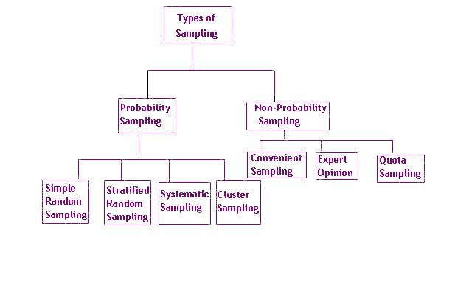
Probability Sampling(Random Sampling)
A probability sampling is a method of sampling that ensures that every unit in the population has a known non-zero chance of being selected. Please note that every potential sample need not have the same chance of selection. Practitioners have been using various forms of random selection the most popular being a random number table. Today, computers have replaced the random number table and the software generates the random numbers in a scientific manner very fast.
Some Key Terms in Sampling
N = Number of units in the Population
n = Number of units in the Sample (Sample Size)Every unit
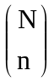= Number of possible selection of n units from N units =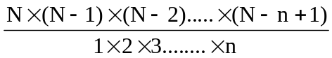 (without replacement scheme)
f = n/N = Sampling fraction

Sampling Frame is a complete list of the units of analysis of interest from which the samples are selected.

Simple Random Sampling

Simple Random Sampling is the foundation of Probability Sampling. It is a special case of probability sampling in which every unit in the population has the same chance of being selected. If you have to select n units out of N units, every possible selection of n units must have the same probability. Can you say how many ways are possible to pick up n units out of N units? Of course you can. Is it equal to ? Yes. Refer the table giving some key terms in sampling in the previous screen. Simple random sampling guarantees that every possible selection of n units from N units has the same probability 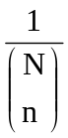. We are assuming here that the units are selected without replacement.

An Example:

A bank wants to do a study on the customers’ perception of its service quality in the last 12 months with regard to the savings bank account holders. First, you have to prepare the sampling frame for this study. You can go through the bank’s records and get a complete list of savings bank account holders. This is your sampling frame. Suppose your sampling frame contains 500 account holders and you have to select 50 out of this 500 and interview them. How to actually draw a sample of 50 account holders out of the 500 account holders?

One method is to prepare 500 small paper slips, each giving the account holder’s name and account number. Put these slips in a container, shuffle the container thoroughly and then select 50 slips one after the other for the container.
The efficient way is to use the Microsoft Excel to accomplish this task. First you enter the list of account holders’ names into a column in the EXCEL spreadsheet. Then, in the next column paste the function =RAND( ) which is Excel’s way of generating a random number between 0 and 1 into the cells. Now sort both the columns namely the list of account holders’ names and the random numbers using the random numbers as the key for sorting. This will arrange the data set from the lowest to the highest random number. All you need to do is to pick up the first 50 names in this sorted list. Very simple. Is it not?

Inline Question:

Probability Sampling is another name for Random Sampling. True or False

Answer: True because in sampling techniques probability sampling and random sampling are synonymous.

You have to select 2 customers out of 10 customers for a depth interview. The number of ways in which you can select 2 customers out of 10 customers is

90

60

45

Answer: The correct choice is c). There are 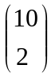 ways in which we can select 2 customers out of 10 customers = (10×9)/(1×2) =45. Obviously the other choices are wrong.

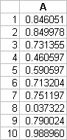
Generate 10 random numbers in the interval 0 to 1 using the paste function RAND ( ) in the Microsoft Excel.

Answer: One set of random numbers using the Excel is given below:

Stratified Random Sampling

Imagine that you are working as a Marketing Manager in a Consumer Product company. Suppose you are studying the customer attitudes towards your product in order to improve your sales. Suppose there are three typical cities that will influence your sales. Suppose the customers within each city are similar and between cities are vastly different. Selection of the customers for the study has to be a random sample of customers chosen from each city so that meaningful and reliable inferences can be drawn which in turn will enable the marketing manager to develop suitable strategies. This is an example of stratified random sampling.
Stratified Random Sampling involves dividing the population into a number of groups called strata in such a manner that the units within a stratum are homogenous and the units between the strata are heterogeneous. Having divided the population into a number of strata, now select a simple random sample of appropriate size from each stratum. The sample size in each stratum is equal to the overall sample size multiplied by the proportion number of units of that stratum to the total number of units in the population. This is called proportionate stratified random sampling. Suppose the overall sample size in a study is set at 200 units. You are interested in working out the sample size for stratum 1. Suppose stratum 1 has a total number of 2000 units and the population has 20000 units. The sample size for stratum 1 is = 200 (2000/20000) =20.
You can also have a disproportionate stratified random sampling that requires some idea of the standard deviation of the distribution of the parameter of interest, within strata. As this information is not easy to obtain managers may have to rely on intuition and logic to determine the sample size for each stratum. For example, bigger retail outlets may have greater variation in sales of certain products compared to small retail outlets. Therefore it is appropriate to have a disproportionately large sample size for bigger retail outlets. One common strategy that mangers follow is that, first select equal sample size from each stratum and then give weights according to the stratum’s proportion of total population.
Stratified random sampling is appropriate when the population is heterogeneous and you are keen to get a realistic picture of the overall population. An ordinary simple random sampling performed on the entire population that is heterogeneous will be highly misleading.
You would prefer stratified sampling to simple random sampling in the case of a heterogeneous population because it assures that you will be able to represent not only the overall population, but also the key strata of the population.

Systematic Random Sampling

In systematic random sampling, the units are drawn from the population at regular intervals clearly defined. It is one of the easiest procedures to follow: The steps involved in constructing a systematic sampling scheme are as below:

Compute K =(N/n) and take the integer value. K is called the sampling interval

Select a random number between 1 and K

Starting with this number select every Kth number until all the n units are selected
Let us take an example to explain systematic sampling procedure: Suppose in a market survey, you have to select 5 households out of 50 households in a Block. The selection procedure is pictured below: The table containing all the households is serially numbered from 1 to 50.
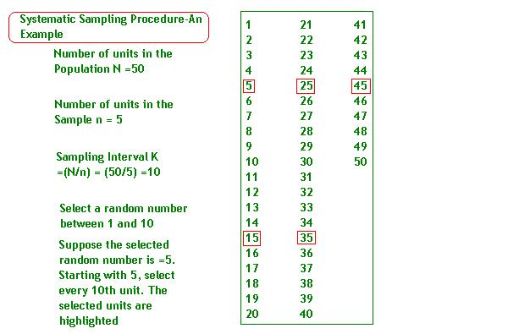
In the systematic sampling procedure, it is necessary that the units in the population are randomly arranged on the basis of the characteristics you are measuring. Why should you use systematic random sampling? First, it is very easy to implement. You just have to select the first number at random. The rest of the units are determined automatically after the first random selection. Secondly, systematic sampling is more pragmatic than simple random sampling. Finally, there are situations where systematic sampling is the only way out especially when you have to strike a balance between precision on the one hand and cost on the other hand.

Cluster Sampling (Area Random Sampling)
One of the problems encountered with probability sampling methods is that you have to apply sampling procedure to a population that is scattered across a number of wide geographic regions. In these cases, you will have to cover a lot of distance in order to have access to the units you propose to sample.

Suppose you want to do a simple random sample survey of all the residents in India who belong to the highest income category. Your interviewers will have to do a tremendous amount of traveling. It is for this reason cluster-sampling method is followed. The steps involved in cluster sampling are:

- Divide the population into a number of clusters based on geographic boundaries
- Select a random sample of clusters from this population of clusters
- Either measure all units within the randomly chosen clusters or do further simple random sampling in each cluster.

Strictly speaking, when you measure all the units in the selected clusters, the procedure is called cluster sampling. Suppose you do further sampling within each cluster by adopting a simple random sampling or stratified random sampling, the procedure becomes a multi-stage sampling.

Inline Questions:
1) In which of the following sampling procedures are the N units in the population are divided into separate groups each with a common characteristic?
- Systematic Sampling
- Cluster Sampling
- Stratified Sampling
Answer: c) is the right choice. In stratified sampling, you divide the population into a number of groups called strata in such a manner that the units within a stratum are similar (common characteristic). Homogeneity within a stratum and heterogeneity among strata are the distinguishing features of stratified sampling. Obviously, the other options are incorrect.
2) A dairy corporation that home deliveries milk in a city would like to estimate the average milk consumption per household per month. If it picks up at random three of its fourteen delivery routes and obtains the relevant information for each household within these three routes, which type of sampling technique it has adopted?
- Stratified Random Sampling
- Systematic sampling
- Simple random sampling
- Cluster Sampling
Answer: d) is the right choice. There are 14 delivery routes, which can be taken as 14 clusters. Three clusters are picked up at random and measurements taken on each household within the three routes (three clusters). This is the very definition of cluster sampling. Other choices are incorrect.

Non-Probability Sampling

The fundamental difference between non-probability sampling and probability sampling is that in non-probability sampling procedure, the selection of the sample units does not ensure a known chance to the units being selected. In other words, the units are selected without using the principle of probability.

Even though the non-probability sampling has advantages such as reduced cost, speed, and convenience in implementation, it lacks accuracy in view of the selection bias. Another negative point of the non-probability sampling is its inability to generalize results from the sample to the population. It is mandatory in inferential statistics to use only probability sampling for valid conclusions. Non-probability sampling is suitable for pilot studies and exploratory research.

Convenience Sampling
Using college and university students in studies involving attitudes towards co-education is basically a matter of convenience. In consumer panel studies you may use clients who are available to you as your respondents for giving their opinion on products and services. In many research projects, you simply look for volunteers to participate. This is how the convenience sampling is done. For heavens sake, don’t generalize results based on convenience sampling
Expert Opinion Sampling
Expert Opinion Sampling involves gathering a set of people who have the knowledge and expertise in certain key areas that are crucial to decision making. In qualitative methods of demand projection for a new product, you use the expert opinion method to arrive at a reasonable forecast. The advantage of this sampling is that it acts as a support mechanism for some of your decisions in situations where virtually no data are available. The major disadvantage is that even the experts can have prejudices, likes, and dislikes that might distort the results.
Quota Sampling:
In simple terms, quota sampling is stratified random sampling without probability principle being applied to the selection of the sample units. Suppose in an opinion study, you want both men and women to participate. You know that in the population category of interest, 65% are men and 35 % are women. If your sample size is fixed at 200, you will have a quota of 130 men and 70 women. It doesn’t matter how you get them as long as you have met the quota. There are some socio economic studies where quota sampling is the only way out because of practical considerations. You can do the descriptive statistics, graphs, charts, and summary table and stop there. That is it. Drawing any possible conclusions from a quota sampling will be highly tentative. None of the statistical inference techniques should be applied when you have followed quota sampling or for that matter any non-probability sampling procedure
7.3 Sampling Distribution –A Conceptual Framework

How do you go about using a sample statistic to estimate a population parameter? To answer this question, you will have to understand the concept of the sampling distribution. The entire inferential statistics is built on the foundation of the sampling distribution.

The probability distribution of all the possible values a sample statistic can take is called the sampling distribution. of the statistic. The key word here is “sample statistic”. Sample mean and sample proportion based on a random sample are examples of sample statistic(s). Please note that we are not interested in the probability distribution of a set of numbers. We are interested in the probability distribution of a statistic which can assume different values in an experiment that involves taking a large number of times random samples of same sample size from a population and computing the statistic afresh every time.

Cautionary Note: There is a feeling among many students that the expression “sampling distribution” automatically implies the sampling distribution of the mean. This is not correct. You can have a sampling distribution of the median as well. Please notice that the sampling distribution of the mean is not the same as the sampling distribution of the median. They are entirely different.

In order to understand the sampling distribution better, let us look at an example. Suppose that you take a sample of four youth from a population of youth numbering 10000. The mean weight of the four youth is worked out. Again take another fresh sample of four youth from the same population and work out the mean weight. If you repeat this process an infinite number of times, the probability distribution of these infinite number of sample means would become the sampling distribution of the mean. Let us assume that the mean weight of the first sample is 65 kg.. The mean weight of the second sample is 70 kg, and so on. Suppose you keep on taking a sample of 4 youth from the same population and keep on working out the sample mean every time, then the mean of the means of the infinite samples will approach the true mean of the population. Let us assume that the true mean is 70 kg. The histogram and the distribution of the sample mean for this example will look like the following bell shaped normal distribution.
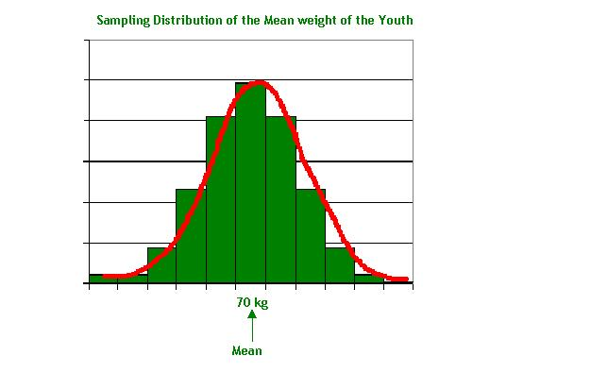
This is the concept of the sampling distribution. Likewise you can also have a sampling distribution of the median if you compute the median of each sample instead of the mean. From the point of view of statistical inference, sampling distribution of the mean is very important. Shortly, we will focus on the sampling distribution of the statistic (mean) when samples are drawn from a normal population. Suppose the original distribution is not normal what happens? Relax! You have the central limit theorem to help you out. Even in the example above, the original population is not normal!
7.4 The Concept of Standard Error

What is the standard deviation of the sample statistic called? Can you guess? It is called the Standard Error of the Statistic. In other words, the standard deviation of the Sample Statistic is called the Standard Error of the Estimate. Please note that any sample statistic is an estimate that is used to estimate the population parameter. The standard deviation of the distribution of the sample means is called the standard error of the mean. Likewise, the standard deviation of the distribution of the sample proportions is called the standard error of the proportion.

Let's explain once more. A standard deviation is the spread or departure of the values from the mean in a single sample. The standard error is the spread or departure of the values from the mean of means in a sampling distribution. You got it now?

In the context of sampling, the standard error is popularly known as the sampling error.
We told earlier that a sample statistic is an estimate. Sampling error throws light on the precision and accuracy of our estimate. The logical question is how to compute the sampling error? Can you say how? Of course you can, if you think intuitively. The larger the sample standard deviation, the larger is the standard error. The larger the standard error, the larger is the sampling error.

Standard Error and the sample Size:

The standard error is inversely proportional to the sample size. The larger the sample size, the smaller is the standard error. Can you guess why? Because, as the sample size increases, the standard error goes on declining and approaches the value zero theoretically when n tends to ∞. In practice, this implies that for a large sample size, the sample mean is almost equal to the population mean barring some minor deviations. In the next module (module 7) you will learn how to determine the sample size for a given situation by using the concept of confidence interval and standard error. At this stage, it is enough if you know how important the standard error is in the context of the sampling distribution.

Sampling Distribution of the Mean from Normal population

If you have gone through the initial discussion on the concepts of the sampling distribution of the mean along with the example given, the sampling distribution of the mean from the normal population is a logical extension of the same principle. The samples are randomly drawn from a normal population with certain mean and standard deviation. The original population is distributed normally. You have a clear structure for the sampling distribution of the mean with terms and notations that are given in the next screen.

Sampling Distribution of the Mean from Normal Population - Statistical Description

- If 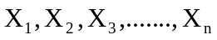 are n independent random samples drawn from a Normal Population with Mean =, and Standard Deviation = , then the sampling distribution of 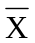follows a Normal Distribution with Mean = , and Standard Deviation =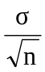.
- =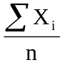= 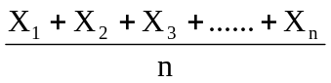 = The Sample Mean. Please note that is a random variable and will be different every time when a fresh sample of n observations are taken.

- is called an Unbiased Estimator of the Population Mean . This implies that
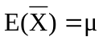. Symbolically this is written as 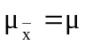.

- The Standard Deviation of the Sample Mean = . This is written as 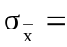.

- 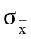 is called the Standard Error of the Sample Mean . As you will appreciate that the standard error keeps on decreasing as n keeps on increasing.

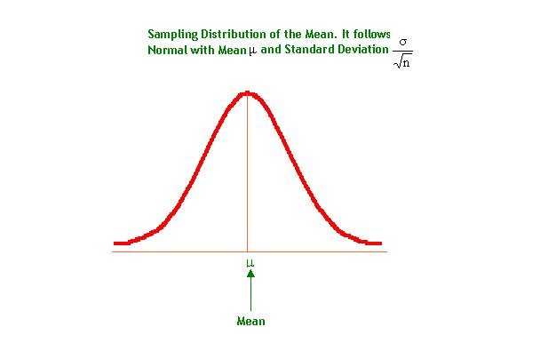

Are the mathematical symbols and expressions in the previous screen confusing and mystifying? Don’t worry. To remove the mystic feeling, let us take the very same example that was discussed earlier in the context of the concept of a sampling distribution. The only modification we make in that example is that the original youth population of interest follows a normal distribution with mean weight 70 kg and standard deviation 5 kg.

Suppose that you take a sample of four youth from this normal population of youth numbering 10000. The mean weight of the four youth is worked out. Again take another fresh sample of four youth from the same population and work out the mean weight. If you repeat this process an infinite number of times, the probability distribution of these infinite number of sample means would become the sampling distribution of the mean. Let us assume that the mean weight of the first sample is 65 kg.. The mean weight of the second sample is 70 kg, and so on. Suppose you keep on taking a sample of 4 youth from the same population and keep on working out the sample mean every time, then the mean of the means of the infinite samples will approach the true mean of the population. So what can you say about this sampling distribution?

- The mean weight of the youth follows a Normal Distribution with Mean = = 70 kg and Standard deviation = =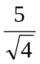 = 2.5 kg. In other words 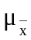 =70 kg and 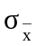 =2.5 kg.

- is an Unbiased Estimator of the Population Mean which says that the . That is the mean of = =70 kg.

- What is the Standard Deviation of the Sample Mean ? Of course it is and is = 2.5 kg. Is not the standard deviation of called the standard error? Yes

- One interesting feature you notice here is that the standard deviation of the original distribution is 5 kg where as the standard deviation of the sampling distribution of is only 2.5 kg. So the standard deviation of the sampling distribution of the mean is always less than the standard deviation of the individual items in the population.

What impact does the Standard Error have On the Sampling Distribution when you increase the sample size? Look at the following diagram.

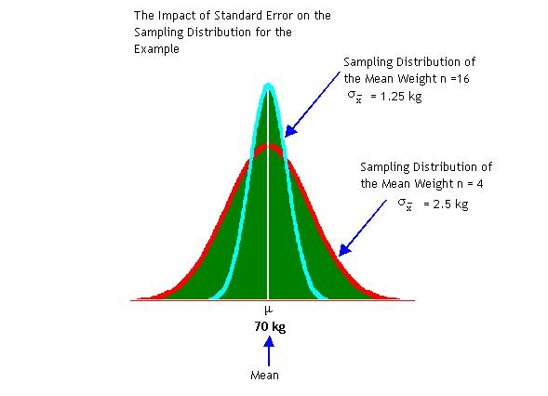

In our example, we have taken that the youth population is normally distributed with mean = 70 kg and a standard deviation = 5 kg. The first experiment involves drawing a random sample of 4 observations from this population and the second experiment involves drawing a random sampling of 16 observations. The two normal distributions have the same mean but the spread is not the same. As you can see the standard error of the sample mean is 2.5 kg when n= 4 and 1.25 kg when n= 16. How far can you go on increasing the sample size? Even though the aim is to reduce the sampling error, you have to strike a balance between the cost on the one side and the accuracy on the other side while working out the optimal sample size. The standard error plays a major role in deciding the right kind of sample size.

Example:
The marks obtained by students in an aptitude test are normally distributed with a mean of 60 and a standard deviation of 20. A random sample of 16 students is drawn from this population.
- What is the standard error of the sampling mean?
- What is the probability that the mean of a sample of 16 students will be either less than 50 or greater than 80?
Solution:

- The standard error of the sample mean is given by = = 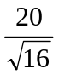 =5
- Let us draw the picture of the sampling distribution of the mean

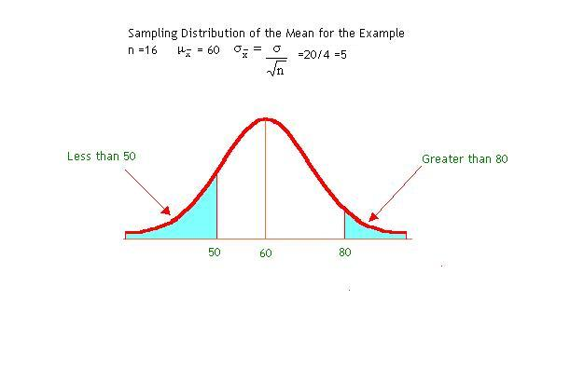
If you add the probability of the shaded area of the two portions, you get the answer. Using the paste function in the Microsoft Excel, you can work out these two probabilities. You don’t even need to convert the original variable into z. Let me show you step by step how to calculate the cumulative probability for portion 1(up to 50) using Excel. Click the paste function and you see the paste function lay out given in the next screen.

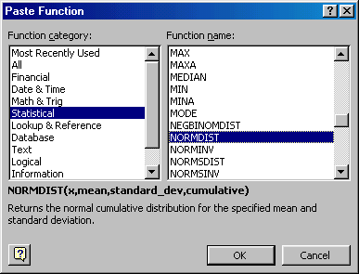

The function NORMDIST is highlighted in the paste function above. Click OK and you get the function NORMDIST. Enter the values in the cells. Now you get the NORMDIST function with values entered given below:

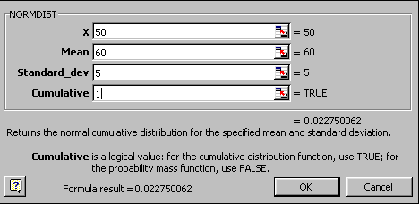

Now either you click OK or alternatively you see the answer corresponding to the “Formula result”. The answer is 0.022750062 or = 0.0228(4 decimal places). The cumulative probability greater than 80 is =1-cumulative probability up to 80. Repeat the same procedure you get cumulative probability up to 80 = 0.99997. The required probability for portion 2 = 1-0.99997 = 0.00003. The answer to the example question is =.0228+.00003 =.0228 (rounded to 4 places of decimal). This means that there is about 2.28% chance that the mean score will be either less than 50 or greater than 80.

Sampling Distribution of the Mean –Non-Normal Population

So far, we have discussed in detail the sampling distribution of the mean when the samples are drawn from a normal population with mean μ and standard deviation σ. We have concluded that the sampling distribution of the mean is also normal with mean and standard deviation . What happens to the sampling distribution of mean when the original distribution is not normal? Mangers in real life situation have to deal with population distributions that are not normal. What do you do? Do you have a solution? Yes. You have fortunately a brilliant and amazing solution provided by the Central Limit Theorem.

In simple terms, the central limit theorem says that from any given population with mean  and standard deviation , if we pick up a random sample of n observations, the sampling distribution of the mean will approach a normal distribution with a mean  and standard deviation as the sample size increases and becomes large. The distinguishing and unique feature of the central limit theorem is that irrespective of the shape of the distribution of the original population, the sampling distribution of the mean will approach a normal distribution as the size of the sample increases and becomes large. How large is large? A thumb rule based on experience says a sample size of 30 and above is considered large. It works reasonably well in a large number of problems. Please remember that n is the sample size for each mean computed and not the number of samples. Also note that theoretically speaking you compute the mean for infinite number of samples. Of course in practice this could mean a sufficiently large number of samples.
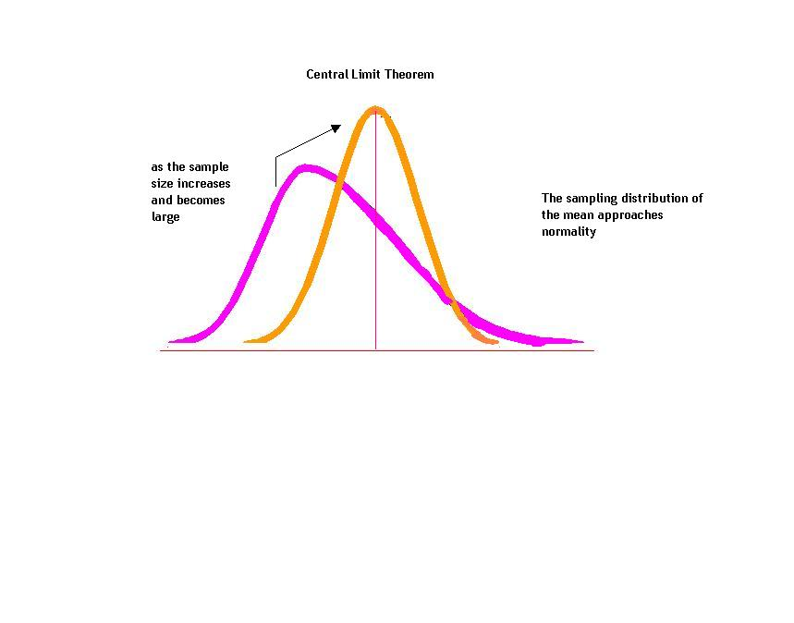
Central Limit theorem is indeed a hallmark of statistical inference. It permits a manager to make inference about the population parameter based on random samples drawn from populations that are not normally distributed. Now you read again attentively the first example we have used to explain the concepts of the sampling distribution. The shape of the curve there is a bell shaped normal because of the central limit theorem.

Assignment: A population consisting of the life of nine brands of tire in 1000 kilometers is given below: Generate all possible random samples of two brands out of nine from this population (without replacement). Compute the sample mean for each sample; draw the frequency histogram for the sample means and comment on the shape of the sampling distribution of the mean. (Use Excel)

Tire Brand | A | B | C | D | E | F | G | H | I
Life | 30 | 29 | 33 | 34 | 31 | 29 | 33 | 33 | 30

7.7 Module Summary

This module has exposed you to the basics of sampling techniques and the concepts sampling distribution. Remember that the entire inferential statistics is built on the foundation of the sampling distribution. In particular, this module focused on:

- The meaning and the need for sampling.

- The types of sampling categorized into probability sampling and non-probability sampling.

- The most widely used sampling methods that include simple random sampling, stratified random sampling, systematic sampling, and cluster sampling under probability sampling and convenient sampling, expert opinion sampling, and quota sampling under non-probability sampling.

- The conceptual framework of the sampling distribution

- The meaning and role of standard error.

- The sampling distribution of the mean from normal population

- The sampling distribution of the mean from non-normal population interwoven with the central limit theorem.

- How to use Microsoft Excel for solution to problems in this module.

Glossary:

Census: Complete enumeration of every unit in the population.

Central limit Theorem: Central limit theorem assures that irrespective of the shape of the distribution of the original population, the sampling distribution of the mean will approach a normal distribution as the size of the sample increases and becomes large.

Cluster sampling: It is one of the probability sampling methods in which the population is divided into a number of clusters. A random sample of clusters is chosen and then all the units in the selected clusters are measured.

Convenience Sampling: It is a non-probability sampling procedure in which you simply look for volunteers to participate in your study. Selection of sample units is just a matter of convenience.

Probability Sampling: It is a method of sampling that ensures that every unit in the population has a known non-zero chance of being selected.

Random Sampling: Same as probability sampling

Sampling Distribution: The probability distribution of all the possible values a sample statistic can take is called the sampling distribution.

Sampling Error: It is the difference between the sample statistic and the population parameter based on a random sample of observations.

Sampling Fraction: It is the ratio between the sample size and population size.

Sampling Frame: It is a complete list of the units of analysis of interest from which the samples are selected.

Simple Random Sampling: It is a special case of probability sampling in which every unit in the population has the same chance of being selected.

Standard Error: The standard deviation of the Sample Statistic is called the Standard Error.

Stratified Sampling: Stratified Random Sampling involves dividing the population into a number of groups called strata in such a manner that the units within a stratum are homogenous and the units between the strata are heterogeneous. Having divided the population into a number of strata, now select a simple random sample of appropriate size from each stratum.

Systematic Sampling: It is a probability sampling in which the units are drawn from the population at regular intervals clearly defined. The regular interval is computed by taking the integral part of the reciprocal of the sampling fraction.

